**Exercise 1: Configuring a Basic Spring Application**

**pom.xml**

package com.library;  
  
import com.library.service.BookService;  
import org.springframework.context.ApplicationContext;  
import org.springframework.context.support.ClassPathXmlApplicationContext;  
  
public class LibraryApp {  
 public static void main(String[] args) {  
 ApplicationContext context = new ClassPathXmlApplicationContext("applicationContext.xml");  
  
 BookService bookService = context.getBean("bookService", BookService.class);  
 bookService.displayBooks();  
 }  
}

**BookService.java**

package com.library.service;  
  
import com.library.repository.BookRepository;  
  
public class BookService {  
 private BookRepository bookRepository;  
  
 public void setBookRepository(BookRepository bookRepository) {  
 this.bookRepository = bookRepository;  
 }  
  
 public void displayBooks() {  
 bookRepository.getBooks();  
 }  
}

**BookRepository**

package com.library.repository;  
  
public class BookRepository {  
 public void getBooks() {  
 System.*out*.println("Fetching books from repository...");  
 }  
}

**applicationContext.xml**

<?xml version="1.0" encoding="UTF-8"?>  
<beans xmlns="http://www.springframework.org/schema/beans"  
 xmlns:xsi="http://www.w3.org/2001/XMLSchema-instance"  
 xsi:schemaLocation="http://www.springframework.org/schema/beans  
 http://www.springframework.org/schema/beans/spring-beans.xsd">  
  
 <bean id="bookRepository" class="com.library.repository.BookRepository" />  
  
 <bean id="bookService" class="com.library.service.BookService">  
 <property name="bookRepository" ref="bookRepository" />  
 </bean>  
</beans>

**LibraryApp.java**

package com.library;  
  
import com.library.service.BookService;  
import org.springframework.context.ApplicationContext;  
import org.springframework.context.support.ClassPathXmlApplicationContext;  
  
public class LibraryApp {  
 public static void main(String[] args) {  
 ApplicationContext context = new ClassPathXmlApplicationContext("applicationContext.xml");  
  
 BookService bookService = context.getBean("bookService", BookService.class);  
 bookService.displayBooks();  
 }  
}

**Output:**

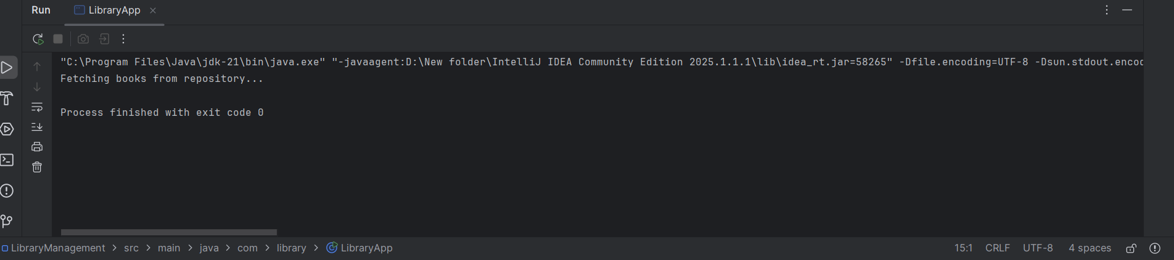

**Exercise 2: Implementing Dependency Injection**

**pom.xml**

<project xmlns="http://maven.apache.org/POM/4.0.0"  
 xmlns:xsi="http://www.w3.org/2001/XMLSchema-instance"  
 xsi:schemaLocation="http://maven.apache.org/POM/4.0.0  
 http://maven.apache.org/xsd/maven-4.0.0.xsd">  
 <modelVersion>4.0.0</modelVersion>  
 <groupId>com.library</groupId>  
 <artifactId>LibraryDIExample</artifactId>  
 <version>1.0-SNAPSHOT</version>  
  
 <dependencies>  
 <dependency>  
 <groupId>org.springframework</groupId>  
 <artifactId>spring-context</artifactId>  
 <version>5.3.32</version>  
 </dependency>  
 </dependencies>  
</project>

**BookService.java**

package com.library.service;  
  
import com.library.repository.BookRepository;  
  
public class BookService {  
 private BookRepository bookRepository;  
  
 // Setter for DI  
 public void setBookRepository(BookRepository bookRepository) {  
 this.bookRepository = bookRepository;  
 }  
  
 public void displayBooks() {  
 bookRepository.fetchBooks();  
 }  
}

**BookRepository.java**

package com.library.repository;  
  
public class BookRepository {  
 public void fetchBooks() {  
 System.*out*.println("Fetching books from repository...");  
 }  
}

**applicationContext.xml**

<?xml version="1.0" encoding="UTF-8"?>  
<beans xmlns="http://www.springframework.org/schema/beans"  
 xmlns:xsi="http://www.w3.org/2001/XMLSchema-instance"  
 xsi:schemaLocation="  
 http://www.springframework.org/schema/beans  
 http://www.springframework.org/schema/beans/spring-beans.xsd">  
  
 <bean id="bookRepository" class="com.library.repository.BookRepository" />  
  
 <bean id="bookService" class="com.library.service.BookService">  
 <property name="bookRepository" ref="bookRepository" />  
 </bean>  
  
</beans>

**LibraryApp.java**

package com.library;  
  
import com.library.service.BookService;  
import org.springframework.context.ApplicationContext;  
import org.springframework.context.support.ClassPathXmlApplicationContext;  
  
public class LibraryApp {  
 public static void main(String[] args) {  
 ApplicationContext context = new ClassPathXmlApplicationContext("applicationContext.xml");  
 BookService bookService = context.getBean("bookService", BookService.class);  
 bookService.displayBooks();  
 }  
}

**Output:**

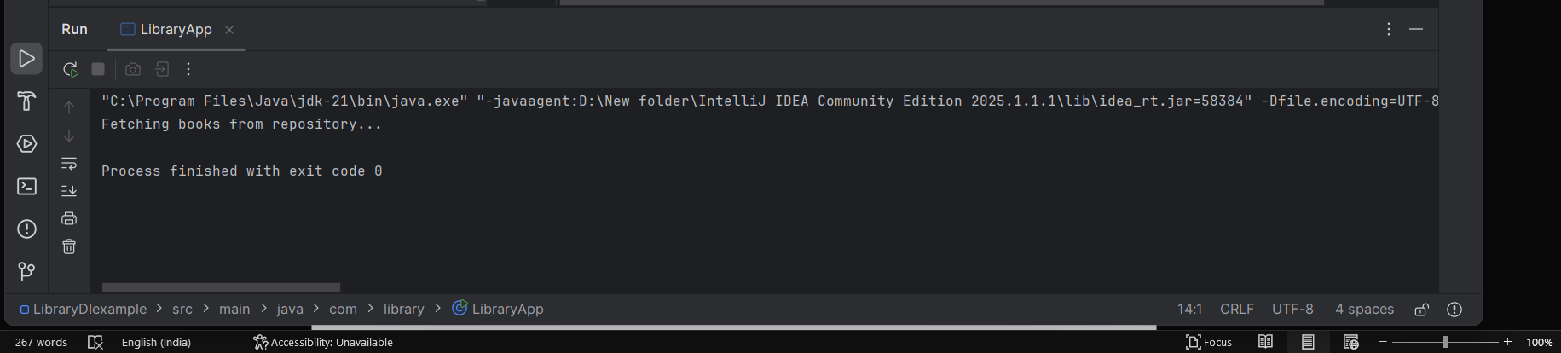

**Exercise 4: Creating and Configuring a Maven Project**

**pom.xml**

<project xmlns="http://maven.apache.org/POM/4.0.0"  
 xmlns:xsi="http://www.w3.org/2001/XMLSchema-instance"  
 xsi:schemaLocation="http://maven.apache.org/POM/4.0.0  
 https://maven.apache.org/xsd/maven-4.0.0.xsd">  
  
 <modelVersion>4.0.0</modelVersion>  
 <groupId>com.library</groupId>  
 <artifactId>LibraryManagement</artifactId>  
 <version>1.0-SNAPSHOT</version>  
  
 <properties>  
 <maven.compiler.source>1.8</maven.compiler.source>  
 <maven.compiler.target>1.8</maven.compiler.target>  
 </properties>  
  
 <dependencies>  
 <!-- Spring Context -->  
 <dependency>  
 <groupId>org.springframework</groupId>  
 <artifactId>spring-context</artifactId>  
 <version>5.3.32</version>  
 </dependency>  
  
 <!-- Spring AOP -->  
 <dependency>  
 <groupId>org.springframework</groupId>  
 <artifactId>spring-aop</artifactId>  
 <version>5.3.32</version>  
 </dependency>  
  
 <!-- Spring Web MVC -->  
 <dependency>  
 <groupId>org.springframework</groupId>  
 <artifactId>spring-webmvc</artifactId>  
 <version>5.3.32</version>  
 </dependency>  
 </dependencies>  
  
 <build>  
 <plugins>  
 <!-- Compiler Plugin for Java 1.8 -->  
 <plugin>  
 <groupId>org.apache.maven.plugins</groupId>  
 <artifactId>maven-compiler-plugin</artifactId>  
 <version>3.8.1</version>  
 <configuration>  
 <source>1.8</source>  
 <target>1.8</target>  
 </configuration>  
 </plugin>  
 </plugins>  
 </build>  
  
</project>

**LibraryService.java**

package com.library.service;  
  
public class LibraryService {  
 public void showWelcomeMessage() {  
 System.*out*.println("📚 Welcome to the Library Management System!");  
 }  
}

**applicationContext.xml**

<?xml version="1.0" encoding="UTF-8"?>  
<beans xmlns="http://www.springframework.org/schema/beans"  
 xmlns:xsi="http://www.w3.org/2001/XMLSchema-instance"  
 xsi:schemaLocation="  
 http://www.springframework.org/schema/beans  
 https://www.springframework.org/schema/beans/spring-beans.xsd">  
  
 <bean id="libraryService" class="com.library.service.LibraryService"/>  
</beans>

**MainApp.java**

package com.library;  
  
import com.library.service.LibraryService;  
import org.springframework.context.ApplicationContext;  
import org.springframework.context.support.ClassPathXmlApplicationContext;  
  
public class MainApp {  
 public static void main(String[] args) {  
 ApplicationContext context = new ClassPathXmlApplicationContext("applicationContext.xml");  
 LibraryService service = context.getBean("libraryService", LibraryService.class);  
 service.showWelcomeMessage();  
 }  
}

**Output:**

